Oxynitride Thin Films: Model Systems for Photocatalysis

Thomas Lippert

Thin Films & Interfaces Group, Research with Neutrons and Muons Department, Paul Scherrer Institut, 5232 Villigen PSI, Laboratory of Inorganic Chemistry, ETH Zurich, 8093 Zurich, Switzerland, and International Institute for Carbon-Neutral Energy Research, Molecular Photoconversion Devices Division, Kyushu University, Japan
Thomas.lippert@psi.ch

Thin films of various materials are utilized in many applications but present also perfect model system to gain a fundamental understanding about material properties and processes/reactions. We focus on the application of lasers for the deposition of thin (oxide) films using pulsed laser deposition (PLD), or pulsed reactive crossed beam laser ablation (PRCLA) to obtain oxide or oxynitride films. Oxynitrides have gained a lot of attention over the last decade due to their photocatalytic properties using visible light. We utilize photoelectrocatalytic measurements (PEC) to study oxynitride thin films, mainly LaTiO_{x}N_{y}. For this approach we developed the deposition method to allow a control over the nitrogen content and crystallinity of the films. One of he first steps was to find a conducting substrate system that allows to perform the photoelectrocatalytic measurements, and an analytical method to quantitatively determine the nitrogen content in the thin films. The photoelectrocatalytic properties of the films were studied as function of crystallinity, orientation, and nitrogen content. The data revealed, that the photocurrent during potentiostatic measurements varied strongly for an initial period, and that potentiostatic measurements allow a direct comparison of different thin films. Clear differences for different crystallographic properties have been found, with absorbed photon to current efficiencies that are higher by a factor 5 for a certain crystallographic orientation (001). We are trying to understand this by performing various surface analytical measurements complemented by modeling and in-operando (in-situ) measurements using the neutron and synchrotron sources at PSI.
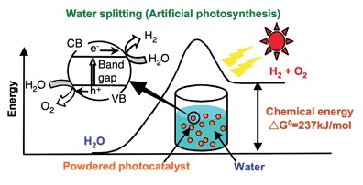
from: A. Kudo and Y. Miseki, Chem. Soc. Rev. 38, 253 (2009).

